Deliverable 6.2: Review & refine existing services in the light of user feedback and usage statistics. Evaluate and refine XML schemas for submitting submission.
Leading partners: Pensoft, NHM

Compiled by:
Lyubomir Penev, Teodor Georgiev, Pavel Stoev, Jordan Biserkov, Margarita Grudova

November 2012

TASK 6.2.1 Users feedback from the questionnaire survey aimed at determining authors and reviewers’ opinion of the currently existing features and editorial workflow of Pensoft’s online editorial system and their attitude towards data publishing

An international online user survey was carried out by Pensoft in the frame of the project ViBRANT. The survey questionnaire consisted of 8 multiple choice questions aiming at receiving feedback from authors and reviewers of ZooKeys on:

Pensoft’s automated email reminders sent out during the editorial and review process

The online editorial platform used by Pensoft

The way people learn about new research articles in their field

Announcement of a manuscript accepted for publication

Authors’ willingness for public papers review process

Reviewers’ willingness for public reviews and identity

Authors’ main motivation to publish their data files in a way that renders them available for use by anyone

Authors’ willingness to publish their data

The questionnaire also allowed the respondents to share their opinions, suggestions and comments through the following 2 open-ended questions:

Please share any other comments, feature requests, appraisals or criticisms that you may have with regard to Pensoft's website or editorial processes

Do you have any other comments or suggestions on the way Pensoft is being run?

In all, 275 completed survey questionnaires were received from 9 to 19 May 2011. The main findings are structured around the questions posed in the survey.

- How do you like Pensoft’s automated email reminders sent out during the editorial and review process
Almost half (47%) of all respondents like the automated email reminders sent out during the editorial and review process because they found they facilitated manuscript tracking. 25% of the respondents remain neutral while 18% did not give an opinion because they never received any automated email remainder. The remaining 10% of responds are shared between: annoying (4%), no answer (4%) and other (2%).

- Fig. 1. A pie chart showing the rated share of respondents’ answers to the question: How do you like Pensoft’s automated reminders sent out during the editorial and review process?
- How do you like the online editorial platform used by Pensoft?
43% of all respondents found it straightforward and easy to use, almost one third (28%) were convinced that it is good but would be improved with instructions for its use and 19% did not give an opinion because they never used it. 7% of the respondents consider that the editorial platform is cumbersome. An insignificant percentage of the respondents did either not give an answer (2%) or choose Other as an answer (1%).

Fig. 2. A pie chart showing the rated share of respondents’ answers to the question: How do you like the online editorial platform used by Pensoft?

- How do you learn about new research articles in your field?
The survey showed that the largest share of respondents (22%) learn about the appearance of new publications in their field of interest from colleagues. Other important sources of information are the general email alerts (16%) and those received as a reviewer or editor of a particular journal (16%) sent from the publisher. The responses “other source” and “conferences” receive 10% each, while announcements sent via electronic mailing lists take up 11% of all answers. The rest of the respondents receive information via search alerts (9%), Facebook (2%), conferences (2%), Mass media (1%), blogs (1%), Friendfeed (1%), RSS feeds (1%) and other (2%).

Fig.3. A pie chart showing the rated share of respondents’ answers to the question: How do you learn about new research articles in your filed?

- Once your manuscript is accepted for publication, would you like to prepare an announcement for any of the following channels?
Over half (52%) of respondents prefer to have their paper announced through an email message sent to a mailing list, while 23% are ready to contribute to the preparation of a press release for the Mass media. 12% of the authors prefer other ways of announcement than those given as a possible answer to this question, another 10% prefer the blog post. The least popular channel is the audio and video commentary, receiving 3% of the answers.

Fig. 4. A pie chart showing the rated share of respondents’ answers to the question: Once your manuscript is accepted for publication, would you like to prepare an announcement for any of the following channels?

- As an author, would you like the review process of your papers to be public?
The majority of respondents (62%) prefer a closed review process versus 18% willing to use a semi-public review process. Only 12% of respondents were in favour of the public review process. 5% of the respondents did not give an answer, while 3% of the authors choose “other” as an answer.

Fig. 5. A pie chart showing the rated share of respondents’ answers to the question: As an author, would you like the review process of your papers to be public?

- As a reviewer, would you like your reviews and identity to be public?
Most of the reviewers (59%) were not willing to reveal their identity and reviews to the public. 19% would go for a public review, but would like to stay anonymous or disclose their names only to registered users of the Pensoft’s Editorial Platform. 8% of the respondents would prefer to have their review exposed to the public but hide their identity, and only 6% of the reviewers would accept to be entirely open to public. 4 % of the reviewers chose “other” and another 4% did not answer the question.

Fig.6. A pie chart showing the rated share of respondents’ answers to the question: As a reviewer, would you like your reviews and identity to be public?

- What would be the main motivation for you to publish your data files in a way that renders them available for use by anyone?
The main motivation for authors to render the raw data underlying the content of the published paper for use by anyone is that open data increases transparency and the overall quality of science (19%) and the data can be used and re-purposed by others (19%). Another clade of respondents (14%) are in favour of the argument that by doing this their research results can be vetted and verified by others. 12% think that this way their data could be integrated with previous and future work, while another 11% believe that data papers will reduce the duplication of effort underlying the collection of data. The answers “Increase of potential for transdisciplinary research” and “Increasing academic credit in the form of citations” were given by 8% of respondents each. An insignificant share of respondents (1%) chose “Other” as a source of motivation.

Fig.7. A pie chart showing the rated share of respondents’ answers to the question: What would be the main motivation for you to publish your data files in a way that renders them available for use by anyone?
8. Would you publish your data?
Over half (55%) of respondents were willing to publish their data provided there was a proper citation mechanism and their work was duly acknowledged. Nearly one third (29%) gave a positive answer to the question versus 8% that don’t feel the need doing that. 6% of the respondents have not answered the question while 2% gave “other” as an answer.

Fig.8. A pie chart showing the rated share of respondents’ answers to the question: Would you publish your data?

The questionnaire also contains 2 optional questions aiming to receive feedback from authors and reviewers. All respondents were invited to share any comments, feature requests, appraisals or criticisms that they may have with regard to the Pensoft's online platform or editorial workflow. 43 respondents provided feedback about Pensoft’s website and their comments are listed below. All authors and reviewers were given the facility to provide comments or suggestions on the way Pensoft is being run, but nobody responded to that.

I probably would not publish my data because it would increase the hours/taxon description to a very high level. Most of the data gets published in descriptive taxonomic papers anyway. For some reason, I received very few automated e-mails during my last publication process, and I would have liked them. However, when I sent an inquiry the editors were very quick to respond.

As an editor I would need to practice the publ. system by some user guide or printed example.

The initial password determination was awkward. It would help if something obvious was in place to assist first-time users.

I feel very comfortable when dealing with Pensoft journals. I see it is one of the best!

As to the open review process you mentioned - generally I am not rejecting this idea, but I suppose that few conditions are necessary to make it really contributive both for the authors and editors: i) the access to the reviews should be regulated at least by the editor - i.e., at least the editor should be aware who is looking at the manuscript and making any notes about. To place the reviews as totally open would, in my opinion, result in tons of critical and often even pointless notes by tons of people and nobody would be able to track if the comments are relevant (i.e. provided by someone with the good knowledge of the topic) or totally irrelevant (i.e. provided by somebody just trying to break the system); ii) in general, I strongly disbelieve anonymous reviewers - anonymous critique which you do not sign is rather frequently just an attack against the respective author or paper. If two reviewers are carefully chosen by an editor, then it is still OK - the reviewers may wish to stay anonymous for many reasons, and the editor may easily distinguish between attacks and relevant critique. If a view audience will provide a critique to an unpublished MS anonymously, it is totally unfair for the author: the author´s work is placed public even before its publication (any of the reviewers may therefore misuse the data), but the reviewers can comment anything without even uncover their identity! Iii) a question at the end: how will you guarantee that the openly places unpublished data will be not misused by anybody before their publication? What if you place openly the MS which will be rejected at the end - then you will even not take care about their publication, but you will only place them public... I would be really careful about such a way, as it may in fact rather discourage the authors from using the journal. I am myself very open with all the data I am publishing (you can find a list of papers in prep., submitted and accepted on my web page, so everybody can see what I am working on just now), but even I would be thinking a lot about a submission of my papers to Zookeys if this would mean that the whole MS of mine would be placed public even before its official publication! And to my knowledge, most colleagues are much less open in sharing their current plans and topics with others than I am!!!

Dislike the layout that shows only some articles from the current issue on the main page and leave a message "this issue may have more articles, click here to view all". All papers from current issue should get the same treatment and be shown on the main page together.

I think you guys are doing a great job, especially in working WITH authors and reviewers.

Website very unclear, it took me quite a while to realize that my manuscript and the editorial files were under 'your tasks'.

Please go on with creating new ways of disseminating knowledge!

So far I have only reviewed a paper, so not much experience with Pensoft. Two months after I submitted my review there is still no editorial decision. It doesn't make me want to publish with you. As a taxonomist I live on a very tight budget, because few funding agencies regard taxonomy as worth funding. Thus paying for publication is out of the question for me, although I am a senior scientist from a developed nation. So I will probably never publish in Zookeys. Many colleagues are in the same situation, which means your selection of papers is biased towards monetary wealth instead of scientific quality.

Personally I do not like peer review, especially anonymously, as it is too open to abuse i.e. political or personal opinions that are uninformed and divisive/destructive. It is also time consuming and only serves those who are on a permanent basis with no need to hurry - they will get paid whatever the product. There could be a clearing house for all published work that can be easily scanned. Paying for subscriptions to journals for articles is a disservice to science as it often tax money that funds these studies and then the unaffiliated public must pay for the product again? What century is this?

Copy Editing and improvement of English should not be done by subject editors and reviewers.

I prefer personal, more detailed and specific answer to the questions posed to Pensoft instead of automatic ones.

Some computers failed to access password section. Work with pdfs requires two-step corrections, while in doc. file the errors and suggestions are directly editable.

There is a little problem of uploading files.

Too-frequent e-mail alerts about books are ANNOYING!

I am a lazy guy when it comes to forms. I imagine the review page is simple enough but I only now am completely familiar with it.

I think you guys are doing a great job.

Review process should be made fully transparent after publication, not during the process, there may be some guys, who are working on the same field and may publish their own paper while a paper is in printing (already happened!!) As a reviewer: a reviewer should be known, if the rev. is doing an integer job, there are no reasons to hide the identity.

Question about publishing "data" is too vague. I would not make available unedited notes or "raw" data, but I would make available "supplementary data" in an edited form where useful. I am strongly in favour of anonymous refereeing and I would not like to see reviews placed online, regardless of whether they are favorable or unfavorable.

Your questions regarding open review as author and reviewer are quite interesting. I always sign my reviews on the one hand so as to remind myself to be fair and constructive and not just rejecting someone else's ideas and on the other hand to provide the possibility to enhance the scientific approach of others (particularly for younger authors or authors from countries with less of an entomological community). However, I am hesitant to be one of the very few who open up their manuscripts or reviews publicly if this is not done by all. This debate is very old and fought from both sides, but ultimately science needs to be open for everybody. I am not a fan of providing access to manuscripts publicly so that they can be reviewed by the community as is done by several new online journals. I basically don't have the time to check all these sites constantly for manuscripts of interest to me and then look at them. My research needs to go first and I am reviewing ""enough"" manuscripts already as well as serve as ZooKeys subject editor and on the editorial board of two other journals. Any way that makes the review process more efficient for authors, reviewers, and editors is welcome and ZooKeys is doing a great job.

Some of the links on the home page don't work, at least some of the time. It seems like they don't work on weekends or off-hours. The problem must be so bad that the "back" button doesn't work and you have to close the window. It's annoying to have to close a window and restart the search again with no assurance of success. After 2 tries I usually give up.

At least twice I have completed an online review, but many days later have been asked by an editor ""where is the review?"" I am not sure why thus happens. Maybe the mechanism for submitting a review should be examined and made foolproof.

Good.

The best way I can increase awareness of my work in ZooKeys is to make the papers indepsensible and publish more than one. I like the open access. I also think it is important for ZooKeys editors to provide a special discount or support for papers like the one I published that have mass appeal and are important or particularly noteworthy.

The only slight problem with the editorial system is that, certainly as first user, you do not know what is asked in future screens. Some reviewers do not understand that uploading is asked in a new screen. It might be handy is that information is given.

Many thanks for your efforts

Research quality in the last 10-20 years has not increased, and where it increased it is not because of peer review, open review, on-line review procedure etc. On-line review process results in reviewers spending less efforts in reviews than earlier when they were marking typos etc by hand on paper; they do not do it so carefully anymore in a word or pdf file. The reminders (most commonly impolitely and aggressively formulated) do not make me happy to work for free for publishers and editors who do not work for free. The anonymous peer review system in specialised fields as in most groups in taxonomy is a joke because the reviewers are easily identifiable; when they are not identifiable they are often off-subject; if they cannot be identified and are aggressive they are usually from students and not really useful. The only thing that really matters in the whole editorial process is the editor. Now, most editors do not read the papers they only read the reviews and blindly ask to follow the reviews without making a judgment of they own. If the author writes in poor English, the reviewers too and the editor does not read the whole paper carefully, then it results in modern unintelligible science.

Students from under developed countries cannot publish their work in your journal as they don't have funds to pay the processing fees or other publication charges.

It is excellent!

The peer review process inherently assumes that the ""peers"" chosen to review are capable of doing so beyond mere technical knowledge of the topic; they must also be capable of being wholly objective and distinguishing between their own personal feelings, like jealousy or personal dislike of the author, and genuine difficulties in the ms. and the work reported therein. When the ""peer"" reviewer isn't capable of these latter elements, (s) he ceases to be both a ""peer"" and a capable and acceptable reviewer. In my experience, ""peer"" reviewers too often fail in the latter categories and attack an ms., and even the author personally, in comments that are deliberately meant to destroy the work simply to boost their own self esteem. Sometimes, ""peer"" reviewers go even farther and attempt in various ways to disguise their true motives with specific comments to this effect. In such situations, ""peer"" review fails miserably, and as an author, I have had this very experience with ZooKeys. The reviewer's personal feelings and/or personal jealousy or antagonism to an author have no place in a truly professional, ""peer"" review. For a reviewer to incorporate in commentaries unnecessarily caustic asides, personally insulting remarks, and to go out of his/her way to demonstrate how much better (s)he would have done a work destroys the ""peer"" review process and the professional credibility of the person conducting the review. In selecting ""peer"" reviewers, ZooKeys should look beyond mere technical competence of the person to that person's ability to distinguish between his/her own personal feelings and genuine difficulties in an author's work. When a person has demonstrated an inability to meet the latter criterion, (s)he should be eliminated as a ""peer"" reviewer regardless of his/her technical knowledge. The point should always be made to reviewers that their task is to HELP an author, NOT to go out of their way to destroy the author's work just so they can feel strong or powerful, and in general, boost their self-esteem and feel better about themselves.

Never know for certain that one has done the right thing! Not intuitive.

Excellent service to the scientific community.

The review system for the most part works well, but it is a little cumbersome and confusing when files are renamed as part of the uploading process. It becomes more difficult and confusing sometimes as to which files are the final (or latest) versions. Also, it is confusing to the submitter (and apparently unnecessary) if, at the final stage when no revisions are required, that he still needs to upload the files again (if there are no changes, then why is that necessary). So the system may be waiting for files, when no additional ones are apparently necessary from the author's viewpoint.

Once I received a paper for reviewing, it was impossible to open it in the way instructed by the editor. After several times without success, he had to send me the ms as attached document.

The Zookeys web pages are a bit overloaded with too many advices and short texts. About publication of data file: yes, but partly regarding taxonomy. Taxonomists are too often the ""small hands"" of more opportunistic and more efficient scientists in the field of Ecology or Molecular biology. It would be sad that they become just producers of data for them. What is needed is that real collaboration arises between these scientific fields, and at the present level of taxonomy, I am sure that making data available for all would be a disaster for taxonomists, they are too weak.

The online platform used by Pensoft is absolutely overloaded due to the frame of link buttons and others. Essential information is not visible at once. Annoying!

I would appreciate an easy way for an editor to access ALL manuscripts he/she is responsible for, e.g. by viewing a list and choosing a certain ms from there. This would also facilitate keeping track with the necessary steps, e.g., being prepared for the next measure to be taken when the ZooKeys automatic reminder comes."

Some important questions are missing, e.g. new articles are usually found by searching the websites of publishers (e.g. Zootaxa, Zookeys) - there should be an item for this.

My experience has not been that anything other than raw data was willing to be shared by most scientists. Many individuals are under contracts with government agencies, which have clauses that restrict or outright prohibit the release of the information other than through a publication. The agency holds the rights to the data. This would limit those authors, such as myself, from being able to do this even though I might be willing.

I would prefer the personal contact with the editor of a given issue even if the automatic email reminder might be more effective in the process. Moreover, the science is not independent from the personality of the experts and researchers and the direct connection with the editor(s) makes the contact of the reviewers more familiar. I believe it has an advantage for both sides, as well as for the author(s) of the manuscripts.

Can a website formed for the entire data, which was already done by Elsevier.

Double-blinded review process is the fairest process.

Conclusion

As a general conclusion the greater part of the respondents like the automated email reminders sent out during the editorial and review process because they found that they facilitated manuscript tracking. The majority of respondents like also the editorial platform developed by Pensoft, as they find it straightforward and easy to use. The most common way to learn about new research articles available in the field of interest was email alerts sent from the publisher followed by direct information from colleagues. As a whole, authors prefer to have their papers popularized in first place by emails sent to specific mailing lists and at second place via press releases from the Pensoft’s Press office. The majority of respondents prefer the closed review process, almost the same percentage of reviewers are not willing to disclose their reviews to the public. The main motivation for people to publish their raw data in the form of data papers and render them available for use by others is that open data increases transparency and the overall quality of science and that data can be used and repurposed by others. Over half of all respondents would publish their data if a proper attribution and citation mechanism were in place, a further third would definitely publish the data they have. Most of respondents consider Pensoft’s editorial platform completely suitable for dissemination of scientific information. The received comments and suggestions for improvement are directed towards:

Making guidelines easier for first-time users

Regulating the open review process

Improving the website interface

Speeding up the editorial decision

Implementing a clearing house mechanism for all published works

Improving the selection of peer-reviewers

Improving the Copy Editing provided by else than editors and reviewers

Improving the feedback feature

Improving the review system

Implementing personalised contact between author and editor instead of automatic email reminder

Task 6.2.2 User’s feedback on the invitation to join the Biodiversity Data Journal Editorial Board

On 22 October Pensoft announced through several channels (taxacom, zookeys, phytokeys and mycokeys mailing lists) the preparation for launching the Biodiversity Data Journal (http://www.pensoft.net/journals/bdj) – a next generation platform for publishing biodiversity science and data. BDJ is currently recruiting editorial specialists who can be involved in the innovative reviewing process and have expertise in dealing with taxon treatments, checklists, genomic-, ecological- and environmental-datasets, analytical methods and software. Potential editors should be interested in new ideas, methods and approaches to publishing, sharing and using biodiversity information. An online registration form has been developed for facility of the process: http://www.pensoft.net/editor_form.html

The announcement has attracted the interest of the world biological community for a very short time. Until 16 November 194 scientists from all over the Globe have expressed their interest to become editors in BDJ. They show a wide range of expertise, from taxonomy (156), to phylogeny, evolution, genetics, biogeography (Fig. 9). Insect specialists have shown highest interest in becoming Subject Editors in BDJ, 83 of respondents have entomological background. The second group of experts is formed by botanists, mycologists and algologists, which amount for about 15% of all respondents. Relatively high interest was shown also by herpetologists (15) and Crustacea experts (14) (Fig. 10). Among entomologists, beetle specialists dominate with 25 respondents, followed by Hymenoptera (7), Trichoptera (6) and Lepidoptera (5) experts.

Fig. 9. A pie chart showing the background of respondents.

Fig. 10. A pie chart showing the taxonomic background of respondents.

Fig. 11. A pie chart showing the taxonomic background of registered entomologists.

Task 6.2.3 Users feedback on the overall structure and functionality of the beta-version of Pensoft Writing Tool.
On 16 August 2012 Pensoft released the “beta" version of the Pensoft Writing Tool (PWT) for testing and invited some of the most active editors or authors of the journals to take part in its testing. In all, five researchers from France, Australia, USA and Germany shared a total of 27 comments on the overall structure, interface and functionality of PWT, which are listed below. Respondents have reported some technical problems and suggested how to improve the interface and functionalities of the tool.

Really good and pleasant to use
- Couplet 4 remained blank even after numerous tries
- Automatically import keys from excel
- Biodiversity data paper. There are *3* different sections where the author defines the study area geographically!
- The purpose of the 2 modes should be made more obvious in the interface
- PWT is quite nice and user-friendly, so congratulations thus far
- In dichotomous keys, characters appear in a fixed order and it may be difficult to assess the state of a particular 'pivotal' character. [You might be able to reference this, as there have been papers detailing the problems with keys.]
- Do we have an option to make the version history of a document public upon publication of the paper?
- Upon saving a revision, I would like to have the option of providing an edit summary (just like at MediaWiki or Git).
- Looks interesting so far.
- Nomenclature section in Article metadata to be renamed to: Classifications
- When looking at reference lists and clicking on Edit button, the Edit form should appear instead of search options
- Avoid section names in the edit forms - they often repeat the names of sections below them
- Clicking on Article metadata field does not make much sense; probably we should open new sub-item - Article templates & Journal
- When clicking on Edit button in authors and contributors list, a misleading button appears above the edit form: + Add author name search - quite confusing!
- There is not clear difference and visualization between general comments generated through the Comment button upper right and comments to selected texts. Probably we could rename the Comment button upper right to "general Comment
- Pages with colored logos of the depository
- Would be great to have a field for the author ZooBank LSID
- Overall the PWT is very clean and self-explanatory. This type of publication is certainly the future facilitating on the one hand easy collaboration with colleagues and on the other hand, and more importantly, store data in a database from where it can be easily used by other researchers
- I very much like the materials feature so that all data can be uploaded to GBIF automatically. This is the way to get high-quality occurrence data of insects into GBIF!
- The key builder is also great.
- The PWT is great and I shall use it for a manuscript soon once it is in publishing mode
- One big minus in terms of user experience as a reviewer: there is no way for me to download all the supplementary files in one go.

Task 6.2.4 Refinement of the XML schemas for submission of manuscript from Scratchpads to ZooKeys
The export of structured content in XML format from Scratchpads to ZooKeys has been exemplified by Faulwetter et al. in a ZooKeys paper published in 2010. The paper deals with a newly described species of marine flat worm found in the Mediterranean sea. The XML schema used in the manuscript was TaxPub, an extension to the Document Type Definitions (DTD) of the US National Library of Medicine Journal Archiving and Interchange Tag Suite (NLM). Since July 2009, TaxPub has been routinely implemented in the everyday publishing practice of Pensoft, to provide: (1) Semantically enhanced, domain-specific XML versions of articles for archiving in PubMedCentral (PMC); (2) Visualization of taxon treatments on PMC; (3) Export of taxon treatments to various aggregators, such as Encyclopedia of Life, Plazi Treatment Repository, and the Wiki Species-ID.net. However, with the development of the Biodiversity Data Journal and Pensoft’s Writing Tool and after consultations with a number of leading bioinformaticians, a number of flaws in the use of TaxPub schema become apparent, especially in regard to the export of manuscripts from Scratchpads to ZooKeys. At first place, TaxPub was originally designed for taxonomic treatments and does not encompass the overall complex structure of a research article. Besides simple taxonomic treatments several other type of manuscripts, such as data papers, software descriptions and checklists, are envisaged for acceptance and publication in BDJ, so the overall XML schema for export from Scratchpads to PWT through the PWT API were significantly expanded to reflect the specifics of each of the different publication templates. In two subsequent meetings held in Sofia (Vibrant meeting, 16-18 April 2012) and Beijing (annual TDWG conference, 22-26 October 2012) a number of important decisions were taken in this connection and a new workflow and XML schema developed. The pilot test is expected to happen by the end of November 2012 when a new species of a millipede will be described based on a semi-automated export from Scratchpads to PWT through the PWT API and published in Biodiversity data Journal.
Fig. 12. A chart showing the XML work flow from Scratchpads to PWT and PJS and integration of the published content into major data aggregators.

Usage statistics

Tables 1-3. Number of submissions, published articles, issues and pages for the first and second period of ViBRANT in ZooKeys, PhytoKeys and MycoKeys, respectively.
ZOOKEYS | First ViBRANT period  2010-12-01 - 2011-11-30 | Second ViBRANT period  2011-12-01 - 2012-11-20
Submissions | 674 | 680
Articles | 423 | 442
Issues | 80 | 94
Pages | 10496 | 10560

PHYTOKEYS | First ViBRANT period  2010-12-01 - 2011-11-30 | Second ViBRANT period  2011-12-01 - 2012-11-20
Submissions | 47 | 76
Articles | 39 | 46
Issues | 6 | 11
Pages | 410 | 968

PHYTOKEYS | First ViBRANT period  2010-12-01 - 2011-11-30 | Second ViBRANT period  2011-12-01 - 2012-11-20
Submissions | 11 | 22
Articles | 8 | 13
Issues | 1 | 4
Pages | 94 | 192

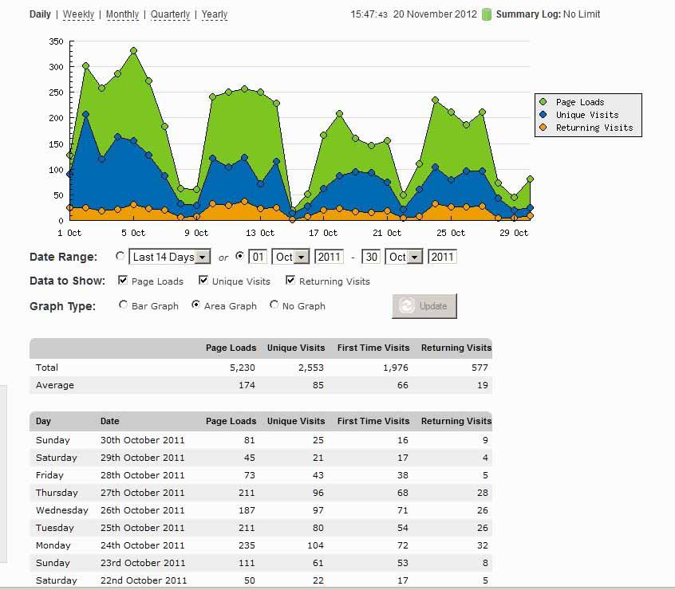 | 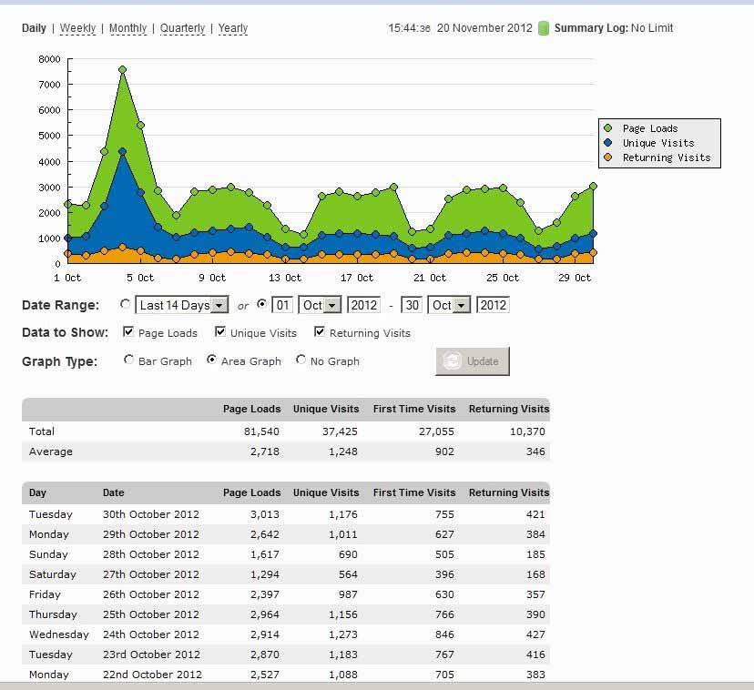

Figs 13-14. StatCount statistics of the user’s activity on the websites of ZooKeys for October, 2012.

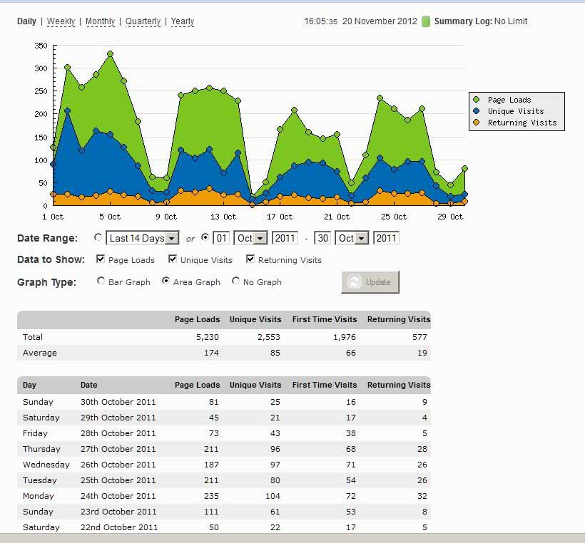 | 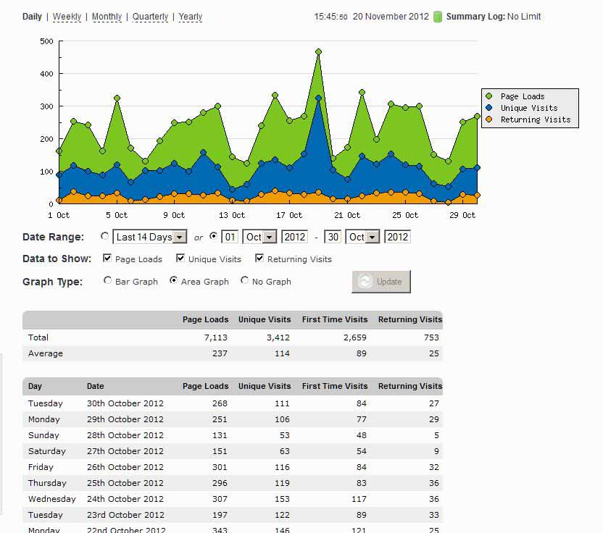
Figs 15-16. StatCount statistics of the user’s activity on the websites of PhytoKeys for October, 2012.

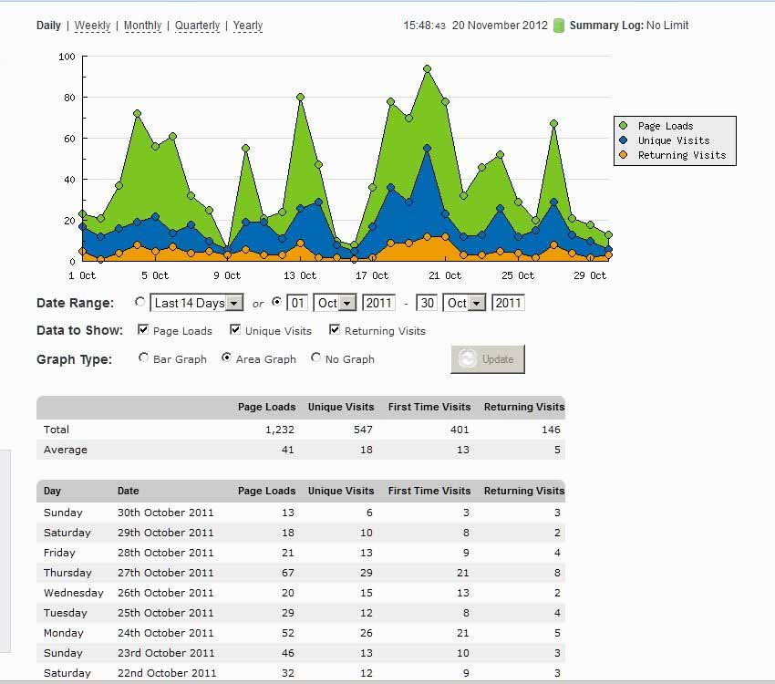 | 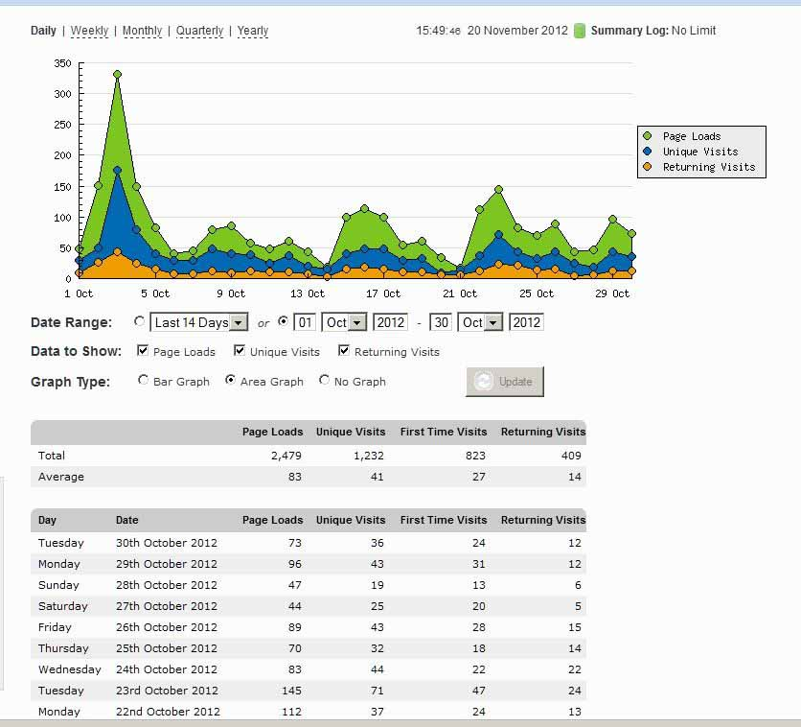
Figs 17-18. StatCount statistics of the user’s activity on the websites of MycoKeys for October, 2012.

Conclusions
The Pensoft’s journals ZooKeys, PhytoKeys and MycoKeys have shown a significant growth with regard to the number of submissions and published content during the second year of the project run, i.e. from 1st of December 2011 to 20th of November 2012 (Tables 1-3). It is especially so for MycoKeys and PhytoKeys showing growth in submissions of, respectively, 100% and 60%. The number of published articles in all three journals (mirrored also by the number of published pages) is steadily increasing too, which means that in general published content maintains its quality, and increase is not due to grow in the low- or medium quality manuscripts. In all, the growth rate for the three journals for 2012 in comparison to 2011 based on the published articles is 7%, but given the fact that the figures do not reflect the entire second period, but only until 20th of November, it is very likely that the figure will further increase with a per cent or more.
Pensoft's innovative approach has been widely welcomed within the taxonomic community as is evident by the largely positive comments received to the surveys and the very rapid response to the call for editors for the BDJ. All this is taken to mean that the strategy we are following is supported by the community and encourages us to continue on the same overall path.
Besides the numerous technological innovations implemented in Pensoft’s journals in the recent years, the increase of the popularity of the company among taxonomists is perhaps also due to the fact that from May 2011 Pensoft opened a press office and started active public relations activities with a number of global science media. The company has developed its own press release template, workflow and strategy for dissemination of scientific information through press releases, news dissemination and policy briefs to which it strictly adheres. The Pensoft PR team offers a support to the authors in “translating” the technical texts into a language that would provoke the interest of the general public. Press releases are posted to a number of sites; primarily EurekAlert!, which is the world largest online distributor of science news supplying information to more than 7500 mass media and independent science journalists.
Pensoft's publications are often reflected by the world science media. For example, the press release Megalara garuda: the King of Wasps on a new giant wasp from Indonesia" described in the Pensoft journal ZooKeys has, in EurekAlert! alone, reached more than 42,300 visits in less than 5 days, while the video associated with another ZooKeys article showing Epomis beetles preying on amphibians (Wizen and Gasith 2011) has been watched 344 325 times over 6 months. The article by Filipowicz and Nee published in Pensoft journal PhytoKeys was featured in a Scientific American article: Genome Run: Andean Shrub Is First New Plant Species Described by Its DNA.
Likewise, the number of unique user’s visits at each of the journals sites has increased in the second period of ViBRANT, too. This is backed up the charts enclosed below.

